Conclusion Features/Usability EE Browser 6.0 Workshop

Workshop held at the 18. April 2012. Main topics were changes for EE Browser 6.0 beta desired by Daimler AG for the final release of EE Browser 6.0.

Participant:

Miroslav Juric (Daimler AG)

Fabian Kliemannel (Intedis)

Markus Böhm (Daimler AG), temporarily present

Stefan Rath(Daimler Protics GmbH), temporarily present

# Usability

## Startup Layout

See Screenshot for standard pane layout. “Drawings hub” is deactivated. “Information hub” is in front of “Modules hub”, e.g. it takes the whole horizontal space.

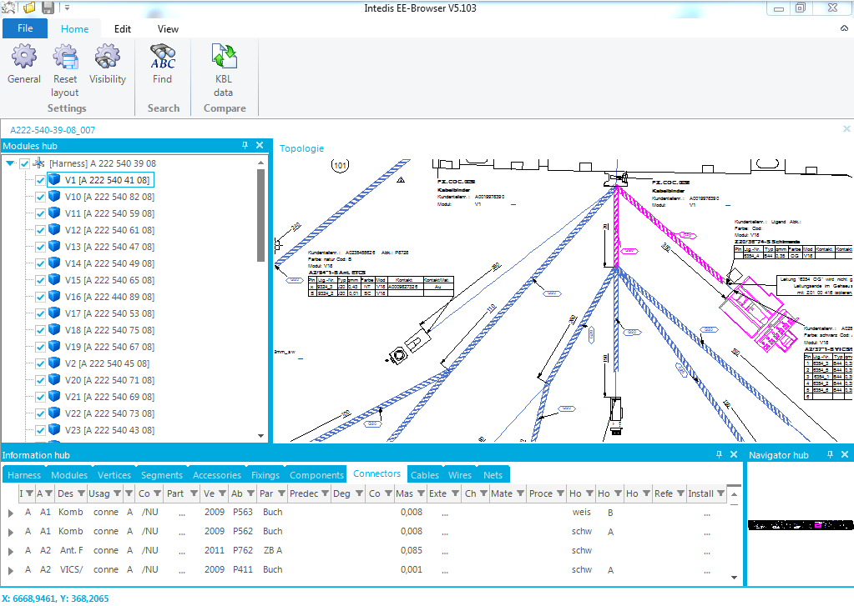

## Open Documents

There should be a dialog for choosing the svg, if there is no “Topologie” svg. The dialog should look like it was in EE Browser 5.5.

## Ribbon Layout:

* File menu:
  + Ok
* Home menu:
  + All important buttons must be on the „Home“ Menu
  + I’m not sure what the “Refresh” button does. If there is no functionality for this button we should remove it.
  + If we can remove the refresh button, home menu should look like this:  
    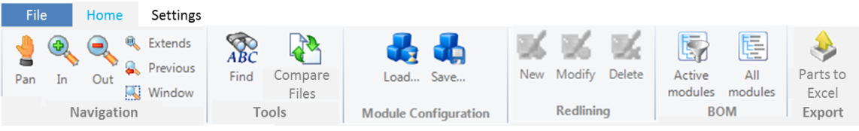
  + If not, it should look like this:  
    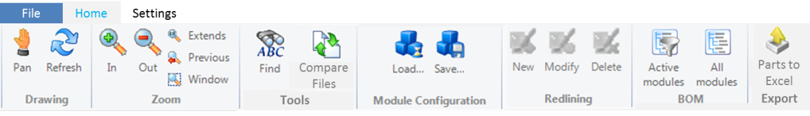
  + “Export parts to excel” is the same functionality like right clicking on “informations hub header and press “export * to excel”. It just represents this functionality in the ribbon menu.
* New menu “Settings”:
  + 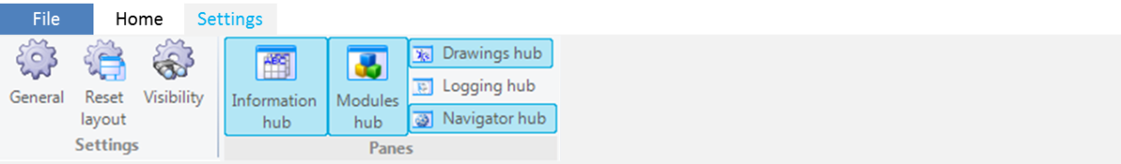

## Information hub standard column order

The column order for the information hub is shown below per column. If a column is not mentioned the order should be taken from EE Browser 5.5. If a column was not in EE Browser 5.5 and is not mentioned it should be placed at the end of the table. In this case the order doesn’t matter.

* Harness tab:
  + “Part number”
  + “Description”
  + New column “ZGS”: take the highest “id” from the included changes.
  + New column “YAP”: take the corresponding “Change request” from the change with the highest id.
  + “Model year”
  + “Degree of Maturity”
  + “Version”
  + „Car Classification 2,3,4“
  + „Company Name“
  + „Changes“ (Button)
  + „External References“ (Button)
* Module tab:
  + „Abbreviation“
  + „Part number“
  + „Description“
  + New column “ZGS”: take the highest “id” from the included changes.
  + New column “YAP”: take the corresponding “Change request” from the change with the highest id.
  + “Mass”
  + „Model year“
  + „Degree of maturity“
  + „Version“
  + „Car Classification 2,3,4“
  + „Company Name“
  + „Changes“ (button)
  + „External references“ (button)
* Segments tab:
  + „ID“
  + “Virtual length”
  + “Physical length”
  + “Cross section area” (if there is just one, show it directly in the column without the additional dialog)
  + Tape:
    - “Part number “
    - “Protection length”
    - “Start location”
    - “End location”
* Accessories tab:
  + “ID”
  + “Part number”
  + “Description”
  + “Abbrevation”
  + “Mass”
  + „Reference element“
  + „Installation Information“
* Fixings tab:
  + „Alias ID“
  + „Part number“
  + „Description“
  + „Abbrevation“
  + „Mass“
  + „Fixing Type“
  + „External References“
  + „Installation Information“
* Components tab:
  + „Part number“
  + „Description“
  + „Abbrevation“
  + „Mass“
  + „External References„
  + „Installation information“
* Connectors tab:
  + „ID“
  + „Description“
  + „Part number“
  + „Part Description“
  + „Abbrevation“
  + „Cavity count“
  + „Housing color „
  + „Housing type“
  + „Mass“
  + „Installation Information“
  + „Cavity“:
    - Description aus Terminal Information
* Cables tab:
  + See wires tab in EE Browser 5.5
  + except „Longname”, this should be shown at the end of the table
* Wires tab:
  + See „Cables tab“ above
  + Show all wires, including the cores of cables. Otherwise it is no longer possible to select all wires routed through a segment.

# Possible new features for Daimler AG

Further specification and investigation is needed for all mentioned features. This is just a short conclusion of the discussion.

## Import of Module Configuration (prio: high)

Daimler wants to import module configuration in the future. An easy way to do is using the windows clipboard and paste a simple line separated list of part numbers (e.g. from Excel). Pasted part numbers get activated, all other part numbers get deactivated. If part number is not present in the current kbl it will be ignored. There is no need to define a new file interface for this approach.

It could be trigger by an button in the ribbon menu in the group module configuration. The name of the button is simply “Paste from clipboard”.

## Analysis views (prio: normal)

Include analysis views like it was in EE Browser 5.5, especially the “Show plating material” and the “show splices” views.

## Cross section area of wires/bundles (prio: low)

In future bundle thickness calculation could be included. When selecting a segment there should be a context menu item for showing the cross section area of the segment. The cross section area needs to be calculated in respect to the module configuration.

Also it is possible to check the cross section area against available space from geometry data. Therefore additional informations are needed (cross section of segments). This data is could be transported via additional kbl files. A user should be able to import the kbl files with additional information into an open hcv file.

## Whole car view (prio: normal)

Open several hcv documents for different harnesses of one vehicle and show the interconnections between them. Somehow there must be an overview which/how harnesses are connected to each other. In addition there should be an feature to view a routing of a “signal” through several harnesses and therefor through several wires.

## Compare of module configurations (prio: low)

Comparison of two different module configurations applied to one hcv file. Which don’t means to simply compare which modules are in configuration 1 and which are in configuration 2, rather than compare the resulting harnesses (wires, connectors, fixings …) of the two configurations.

## Quick Print (prio: low)

Quick print to print the current view of the harness drawing. In best case the print starts without any dialog. The last printer and settings are used (See MS Word).